**Ravinit Chand**

**Revanth Rao**

**NBA All Star Project**

**Introduction:**

Basketball has become one of the most popular sports in the world, with the NBA serving as the premier basketball league in the world, employing top talent such as LeBron James, Stephen Curry, and Kevin Durant to name a few. One common quibble among great players in the NBA is back to backs, an aspect of the schedule which requires teams to play games on consecutive days. Players feel that the back to backs put excessive strain on their bodies given the lack of rest between games, and many players have begun sitting out the second game of a back to back to prevent injury. Our project analyzes common basketball statistics to investigate whether player performance truly suffers on the second night of a back to back, or if NBA players exhibit similar performance despite the lack of rest on back to backs.

**Data Description:**

Our data contains two datasets, with one containing the regular season stats of NBA players, and the other containing the game logs of NBA players for games on the second night of the back to back. The NBA players in the data sets are the 2023 NBA all stars because we wished to examine the performance of the star players in the NBA, and the data contains statistics for the 2022-2023 NBA season. Both of the datasets have many statistics for each player, but the main three we will examine are points, minutes played, and field goal percentage as these are statistics we believe may be affected during a second game of a back to back.

**Points:**

Our first statistic we examined was points. Here, we subtracted the player’s average points per game on the second night of a back to back from the player’s points per game during the regular season. With NBA players complaining about the lack of rest on the second night of a back to back, it would be logical if this value was positive, therefore showing that players put up less points on the second night of a back to back in comparison to their regular season stats. However the average difference was -0.417, implying that all stars actually increased their points average with the lack of rest on the second night of a back to back. The overall scatterplot of each All Star is depicted in Figure 1.

We wanted to look more into this, so we categorized players based on their ages to see if a specific age group stood out. To do so, we created three age groups, which were ages 21-26, 26-33, and 33+. We chose these age groups since they were a good representation of ages for NBA players before, during, and after their prime. When doing so, we found that the age group of 21-26 had a value of 0.58, 27-32 had a value of -1.8, and finally -0.8 was the value for the age group of 33+. The only age group that saw worse performances in terms of points on the second night of a back to back was the younger age group, which could be due to these NBA players still being new to the NBA and not knowing how to adjust with less rest.

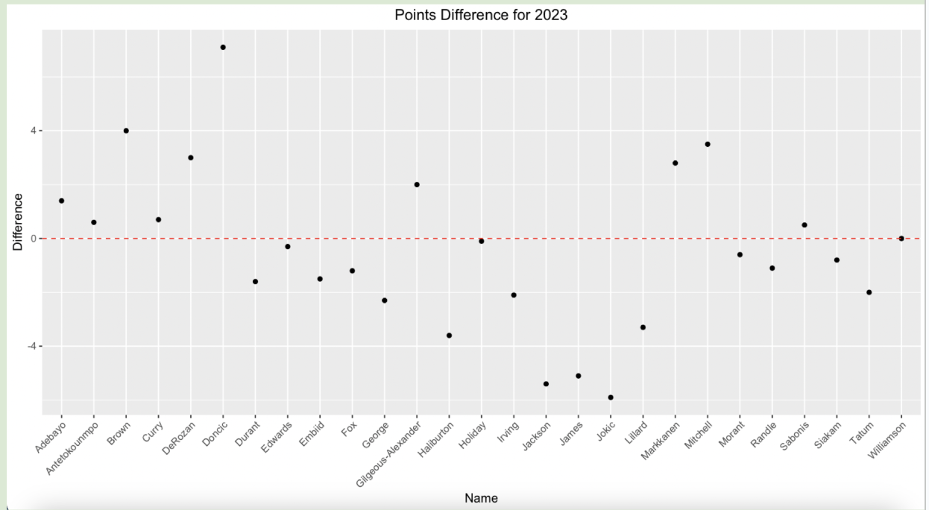

Figure 1: Point Difference For 2023 All Stars

**Minutes:**

Our second statistic we used in this project was the average minutes during a game. The formula was the same format as points, which was average minutes during the season minus average minutes on the second night of a back to back. Our average value across all All-Stars was -0.63, which implies that the All-Stars played roughly 36 more seconds on the second night of a back to back in comparison to the average game in the regular season. This was really surprising to us because we believed that the players would play less minutes on the back to back with less rest.

Additionally, the scatter plot labeled by Figure 2 depicts a graphical representation of the equation, which looking further into the specific players, made lots of sense to us. The scatter plot made sense because players with negative differentials (played more on back to backs) are players known to be durable and relatively young during the 2022-23 NBA season. For example, out of the 7 players that had the lowest scatter plot points (Adebayo, Brown, Durant, Jackson, Jokic, Tatum), 6 of them were less than 30 and 5 of them played at least 80% of the season. We noticed that Kevin Durant was the main outlier for playing more on back to backs, because he played just 47 games and was 34 years of age yet played over two more minutes on the second night of a back to back in comparison to his average minutes.

Conversely, there were only 8 players that played less on back to backs, which we saw have an opposite effect but to less of an extent, where these players are usually older or more injury-prone. Out of the 8 players (Curry, Doncic, Embiid, Gilgeous-Alexander, Holiday, Markkanen, Morant, Williamson), Steph Curry and Jrue Holiday were both in year 14 while Morant, Williamson, and Embiid all had a track record of getting injured a lot that season. As for Doncic, Gilgeous-Alexander, and Markkanen, we weren’t sure why they played less on the second night of back to backs.

Finally, as for the same 3 age groups, the value got less negative as the age group got older, which was not surprising to us since this implies that older players played less on the second night of a back to back in comparison to their average minutes. However the values were around -0.8, -0.5, and -0.1, so looking further into the values, the minutes only had a 42 second difference at most, which isn’t much.

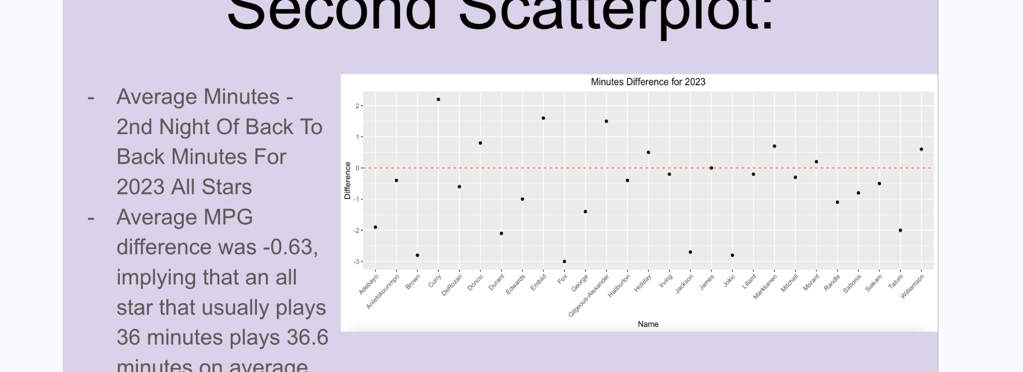

Figure 2: Minutes Difference For 2023 All Stars

**Field Goal Percentage**

The final statistic we investigated for this project was field goal percentage. We chose to examine this statistic because players often complain of fatigue when playing back-to-back games, and conventional basketball wisdom suggests that players shoot less efficiently when they are tired. Thus, we would expect that players have lower field goal percentages on the second night of a back-to-back due to the lack of rest. As with the previous statistics, we subtracted the player’s average field goal percentage on the second night of a back to back from the player’s field goal percentage for the entire regular season. This calculation produced an average difference of 2.4%, meaning that 2023 NBA All-Stars had field goal percentages that were 2.4 percentage points lower on the second night of a back to back than over the full season. The sign of this value being positive was extremely logical in our eyes, as it certainly matches the general consensus on the relationship between fatigue and rest and shooting efficiency.

Figure 3 displays the scatterplot of the difference in field goal percentage as described above. As shown, the majority of players who were 2023 NBA All-Stars have positive differentials, meaning they shot better over a full season than they did on the second night of a back to back. Many of the players who were in the negative range were younger players such as Adebayo, Gilgeous-Alexander, Haliburton, Jackson, Makkanen, and Morant. The only veteran NBA player with a negative differential was Kyrie Irving. This trend makes plenty of sense, as we would expect that younger players have less wear-and-tear and are able to recover more quickly than more experienced, older players. As such, they are likely to be less fatigued when playing a second game in two days, and consequently their shooting will not suffer despite the lack of rest between games. On the other hand, all the oldest players in this sample, such as Curry, Durant, James, Holiday, had positive differentials, suggesting that their shooting efficiency was affected by their fatigue when playing back-to-back games. These findings were again logical and matched our previously held beliefs on shooting efficiency and fatigue.

Finally, looking at the breakdown by age groups, players aged 21-26 had a field goal difference of 0.0857%, players aged 27-32 had a field goal difference of 5.28%, and players aged 33 and older had a field goal difference of 4.1%. All of these figures are positive, indicating that regardless of age, players perform at least slightly worse when playing a back to back game. However, the differential is essentially 0 for the youngest players, while the difference was over 5 percentage points for players ostensibly in their prime and over 4 percentage points for older players. This suggests that back to backs have little effect on shooting percentage for players under 26, while they have a more substantial effect on older players. It was slightly surprising to see that older players had a smaller difference than players in their prime, but we could attribute this to the fact that many veteran players rest on the second night of a back-to-back, often when they need rest or are nursing a minor injury, so their stats are slightly skewed by the fact that they largely only play on nights when they are close to fully healthy. On the other hand, players who are 27-32 are often expected to play essentially every game when healthy, so their statistics may suffer on nights when they play at less than full strength.

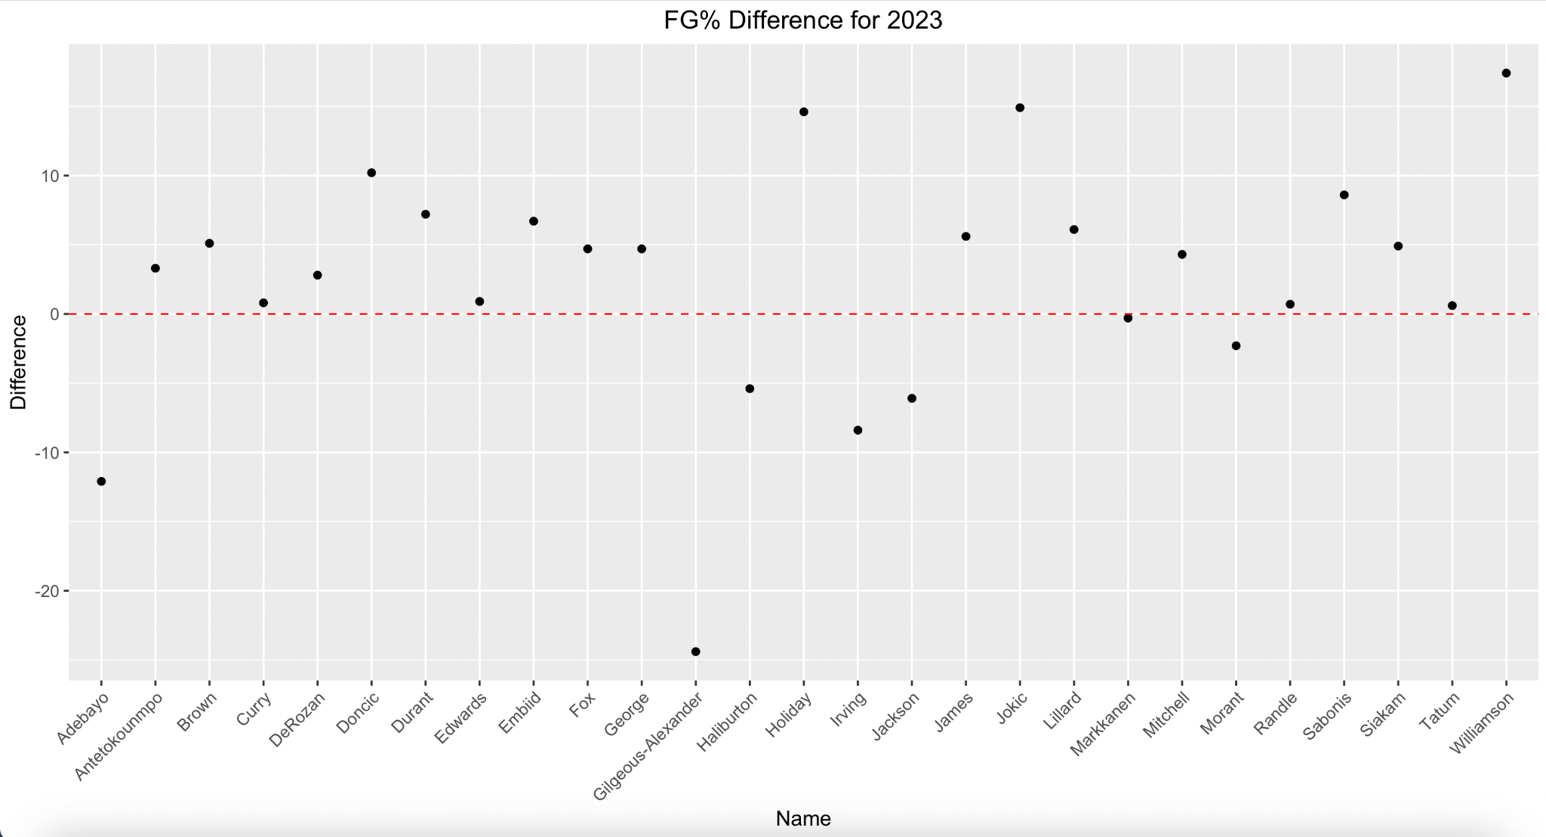 Figure 3: Field Goal Percentage Difference For 2023 All Stars

**Hypothesis**

To investigate the difference in performance over a full season versus the second night of back to backs using statistical methods, we performed hypothesis testing on the three statistics mentioned above. We used two-sample t-tests for each statistic, with one sample being the per-game statistics for each player over a full season and the other sample being the player’s per-game statistics on the second night of a back-to-back. After performing these tests, we obtained a t-statistic of -0.04 for the hypothesis test for points, a t-statistic of -0.12 for the hypothesis for minutes, and a t-statistic of 0.13 for the hypothesis for field goal percentage. The corresponding p-values for these tests were 0.97 for points and 0.90 for minutes and field goal percentage. As these values are far larger than any reasonable value of alpha used in hypothesis testing, we can fail to reject the null hypothesis that there is no difference in the mean points, minutes, or field goal percentage over a full season versus on the second night of a back-to-back for 2023 NBA All-Stars. Additionally, using statistics for the previous five years yielded similar results, as these hypothesis tests also produced p-values that were too large to reject the null hypothesis. As such, we concluded that based on the hypothesis tests, there is not a significant difference in points, minutes, or field goal percentage on back-to-backs as compared to the full season.

**Conclusion**

When looking at the overall results of the difference between the second nights of back to backs to average regular season stats, we concluded that the NBA should not lower the amount of back to backs, as all star performances from our three metrics (points, field goal percentage, and minutes) did not see much of a difference. Although players do complain about back to backs, if their game actually was significantly worse on back to backs, then the NBA would be much more likely to ban back to backs which is not the case here. Overall the field goal percentage saw a dropoff of 2.4% which might seem somewhat concerning, but in the bigger picture that’s only the all star missing one less shot than they usually do on average. Minutes were completely not in favor of banning back to backs as we saw these all stars playing more on the second night of back to backs, and same as points as they also increased on the second night of back to backs. So while all stars can continue to complain about back to backs, their games aren’t affected much by the less rest that back to backs put on their bodies, which only creates a harder argument to ban back to backs altogether.